GMIT H Dip in Data Analytics
Computational Thinking with Algorithms Problem Sheet
Patrick Moore G00364753

Question 1
Consider the following method:
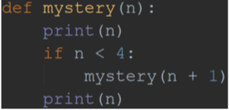

What will the output of the call mystery(1) be?
Write an explanation of the reasoning behind your answer, using the aid of either a recursion trace diagram or a stack diagram. Include any code which you write for testing or explanation purposes as part of your answer.
Answer for Question 1
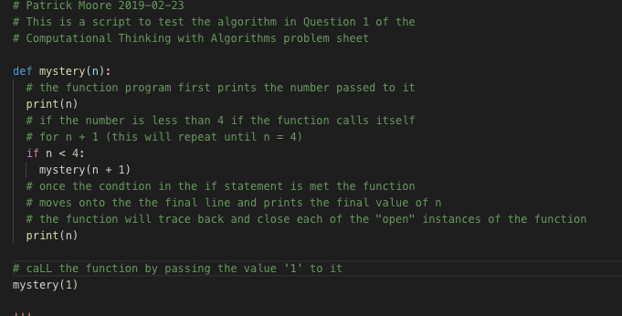
In order to test this, the method was coded in Python in Visual Studio code, and then called by passing the value ‘1’ to it. The source code for this is included with the submission as Q1.py

The output of this function call is shown below:
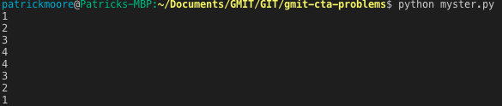
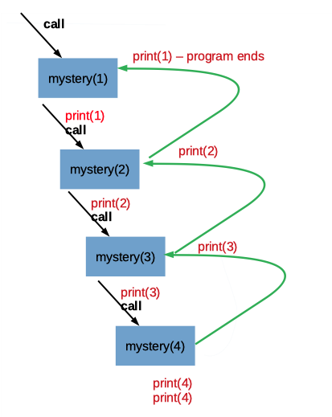
The recursion trace for the call “mystery(1)” is shown below with the original function.

- When the function is called with the original value for ‘n’ set to 1, the first thing the function does is print out this value (1 in this case)
- It then checks if the value passed for n is less than 4. If this is the case the function will recursively call itself for the case ‘n + 1’ (2 in this case). (Note that the recursion will continue until the base case of n is greater than or equal to 4 is met. Also note that the recursion is making progress towards the base case as on each subsequent call, the new value for n is closer to 4)
- The function call with the value of n set to ‘2’, first prints out ‘2’, and again checks to see if n is less than 4. It is less than 4, so it calls the function again with n = 3.
- This third call of the function prints out ‘3’ and checks to see if n is less than 4. It is still less than 4, so the it calls itself with n = 4.
- The 4th call of the function prints out ‘4’ and checks to see if n is less than 4. It isn’t, so the function moves down to the last line in the function and prints out ‘4’ again and finishes.
- Now, the third function call can move onto the final line in the function and print out its value for n (‘3’) and finish.
- Then, the second call of the function can move onto the final line in the function and print out it’s value for n (‘2’) and finish.
- Finally the initial call can move down to the last line in the function, printing it value for n (‘1’).
- The program terminates at this point

Question 2
Consider the following methods:
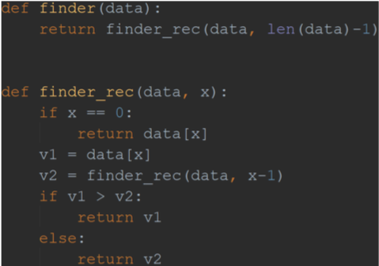

Q2 (a) What value is returned by a call to finder when the following array is used as input? [0, -247, 341, 1001, 741, 22]
Q2 (b) What characteristic of the input data set does the finder method determine? How does it determine this result?
Q2 (c) Can you add some inline comments to the code above to explain how it works?
Q2 (d) Write a method which achieves the same result as finder, but which uses an iterative
approach instead of recursion.
Write an explanation of the reasoning behind your answers to the above questions, using the aid of either a recursion trace diagram or a stack diagram for Q2 (b). Include any code which you write for testing or explanation purposes as part of your answer.

Answer for Question 2
2(a). In order to determine the output of the functions, they were coded in Python in Visual Studio Code as follows:
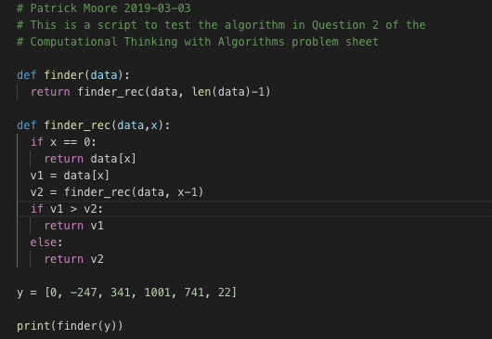

The script was ran from the integrated terminal in Visual Studio Code
The output of this code is 1001

2(b). The finder method takes a data array as an input and returns the value of the largest number in the array. In order to determine how the method worked I added some print() statements to the code to track the values of the variables at each stage in this recursive process. I have included the source code in the submission as Q2b.py.
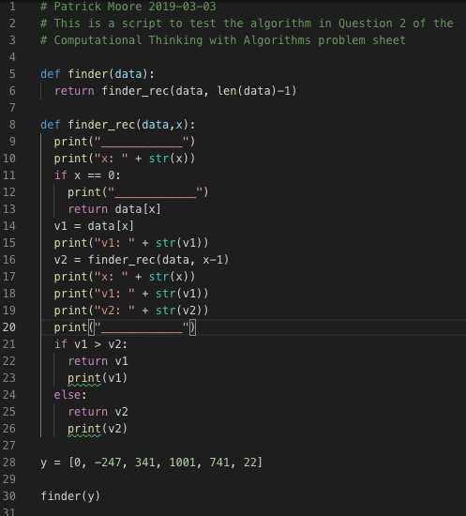

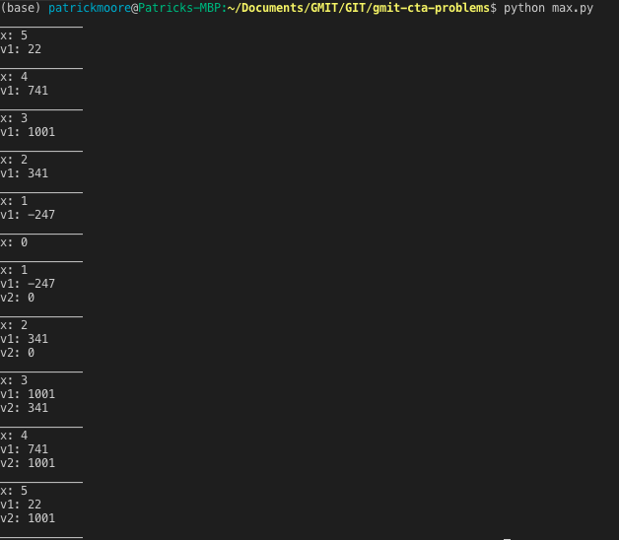
The output of this code is now:

This simplifies the process of creating a recursion trace for the call described in the problem:
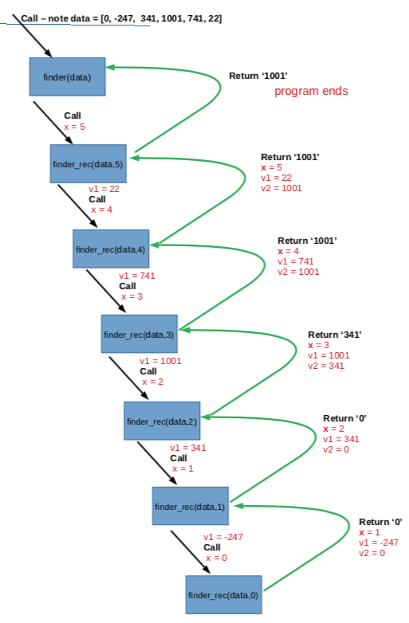

The recursive trace for this program works as follows:
- When the finder([0, -247, 341, 1001, 741, 22]) function call is made, the finder() function calls the finder_rec() function, passing the original list (data)and the index of the last position in that list (5 in this case) as arguments.
- The finder_rec(data, 5) first checks to see if the passed index (x) is equal to zero, if this is the case it will return the first item in the list. Note that this represents the base case for this recursive process.
- For the initial call, x is equal to 5, so it sets a variable v1 equal to the number at index 5 (22 in this case. It sets another variable, v2, by calling finder_rec(data, 4)
- When finder_rec(data, 4) is called we have not yet reached the base case so it sets it’s variable v1 equal to 741, and it’s v2 variable equal to the recursive call finder_rec(data, 3)
- When finder_rec(data, 3) is called we have not yet reached the base case so it sets it’s variable v1 equal to 1001, and it’s v2 variable equal to the recursive call finder_rec(data, 2)
- When finder_rec(data, 2) is called we have not yet reached the base case so it sets it’s variable v1 equal to 341, and it’s v2 variable equal to the recursive call finder_rec(data, 1)
- When finder_rec(data, 1) is called we have not yet reached the base case so it sets it’s variable v1 equal to -247, and it’s v2 variable equal to the recursive call finder_rec(data, 0)
- When finder_rec(data, 0) is called we have now reached the base case (x == 0) so we return the first item in the list to the finder_rec(data,1) function call. This just so happens to be 0 in this case.
- So in the finder_rec(data, 1) call, v1 is still equal to -247, and v2 is now 0, so the function checks to see the bigger number and returns it (closing out this instance of the function). 0 is the larger number so it gets returned to the finder_rec(data,2) function call.
- In the finder_rec(data, 2) call, v1 is still equal to 341, and v2 is now 0, so the function checks to see the bigger number and returns it (closing out this instance of the function). 341 is the larger number so it gets returned to the finder_rec(data,3) function call.
- In the finder_rec(data, 3) call, v1 is still equal to 1001, and v2 is now 341, so the function checks to see the bigger number and returns it (closing out this instance of the function). 1001 is the larger number so it gets returned to the finder_rec(data,4) function call.
- In the finder_rec(data, 4) call, v1 is still equal to 741, and v2 is now 1001, so the function checks to see the bigger number and returns it (closing out this instance of the function). 1001 is the larger number so it get returned to the finder_rec(data,5) function call.
- In the finder_rec(data, 5) call, v1 is still equal to 22, and v2 is now 1001, so the function checks to see the bigger number and returns it (closing out this instance of the function). 1001 is the larger number so it get returned to the finder(data)function call.
- finder(data) can now return the value 1001 as the largest item in list and the program can now close out.

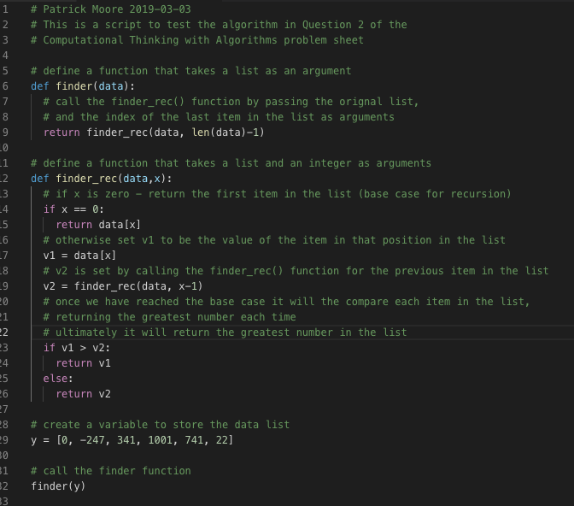
Q2 (c) I have added some inline comments to the code to explain how it works. I have included the source code in the submission as Q2c.py Please see below

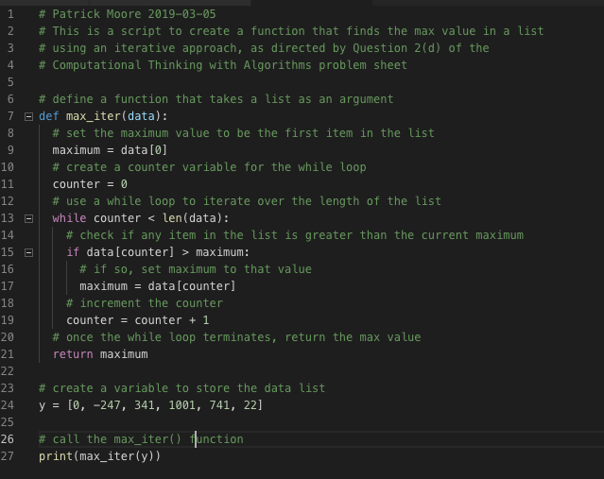
Q2 (d) I have written a function in Python to determine the largest item in a list of numbers using an iterative approach instead of a recursive one. I have included the source code in the submission as Q2d.py This is shown below:

Question 3
Consider the following method which checks if an array of integers contains duplicate elements:

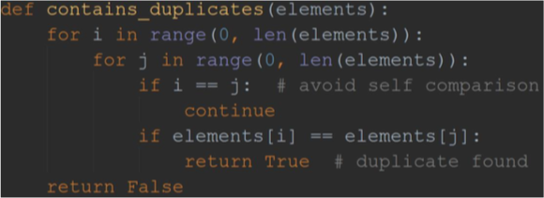

Q3 (a) What is the best-case time complexity for this method, and why?
Q3 (b) What is the worst-case time complexity for this method, and why?
Q3 (c) Modify the code above, so that instead of returning a boolean indicating whether or not a duplicate was found, it instead returns the number of comparisons the method makes between different elements until a duplicate is found.
Q3 (d) Construct an input instance with 5 elements for which this method would exhibit its best-case running time.
Q3 (e) Construct an input instance with 5 elements for which this method would exhibit its worst-case running time.
Q3 (f) Which of the following input instances, [10,0,5,3,-19,5] or [0,1,0,-127,346,125] would take longer for this method to process, and why?

Answer for Question 3
3(a). The algorithm used for the function contains_duplicates() is a simple “brute force” method that checks each combination of numbers and stops as soon as it finds a duplicate. It does this using nested for loops. In the outer for loop (the one with “i” as the counter), the function starts at the first item in the list and iterates through each item in the list. The inner for loop (the loop with “j” as the counter) is then used to compare each item against each value for “i”. The function has a safety system built into it to skip over self comparison (i.e. it wont compare the nth item in the list to itself). The other interesting fact about this function is that is is designed to terminate and return a value of “True” if at any stage it finds as comparison.
This means that the if the first 2 items in the list (items at index 0 and 1), are the same, the function will compare the first item with itself, and skip over it. It will then compare the first item in the list to the second item in the list. As they are the same it will terminate after 2 comparisons. This is the best case time complexity for this method and is said to be “constant time” denoted as O(1).
3(b). As described in 3(a) above, the algorithm is a brute force method that compares each combination of numbers in the list and stops once it has found a match. So this means that the worst case scenario for this algorithm is when a list that contains only unique elements is passed to it. In this case, the function will iterate through each item in the list, and for each iteration it will also need to iterate through each item in the list to make a comparison. As there are no duplicates it the worst case scenario it will run to the end making n² comparisons (where in the number of unique items in the list. The worst case time complexity is said to depend on the square of the number of elements in the list and is denoted as O(n²).
3(c). The code in the function from questions 3(a) and (b) was rewritten to include a counter to count the number of comparisons made. As in the original function, it stops once it finds a matching pair, but instead of returning a boolean True or False, it returns the value of the counter at that point. Note that I decided to only count the comparisons between the various elements in the array – I have not counted the operation to compare the indexes in order to avoid self comparisons. The source code for this is included in the submission as Q3c.py. This code is shown below:
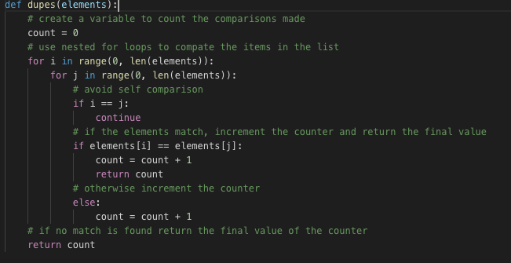
3(d). As described in question 3(a), the best case scenario for this for this function would be when the first 2 items in the list match. So an input instance where this function would exhibit its best case running time would be: list = [1,1,2,3,4]. I have tested this with the code I wrote for question 3(c) and it terminates after 1 comparison. (note that my function is designed to only count the element comparisons, not the index comparisons, so it only starts to count from when it compares the first item in the list to the second one.)
3(e). As described in question 3(b), the worst case scenario for this function is when there are no matching items in the list. So an input instance where this function would exhibit its worst case running time would be: list = [1,2,3,4,5]. I have tested this with the code I wrote for question 3(c) and it terminates after 20 comparisons. (note that my function is designed to only count the element comparisons, not the index comparisons, so it will count a total of (n² – n) comparisons – which is 20, when n is equal to 5)
3(f). [10,0,5,3,-19,5] should take longer to process than [0,1,0,-127,346,125]. The reason for this is that the function is set up to loop through the lists from left to right. If you take the first array, the function will loop through the list comparing ‘10’ to everything and it wont find a match (making 5 comparisons), it will then loop through the list comparing‘ 0’ to everything and it wont find a match (making another 5 comparisons). Finally it will loop through the list comparing ‘5’ to everything and it will terminate at the end of the list (as 5 is the last number in the list). The function will have made a total of 15 comparisons before finding a match and terminating.
Considering the case where the second list is passed to the function. The function will start by comparing ‘0’ to every other item in the list. After making 2 comparisons it will terminate at 0 is the first item in the list and the third item in the list.
Note that I have tested this using the function I created for 3(c) and proven these results are expected. See below:

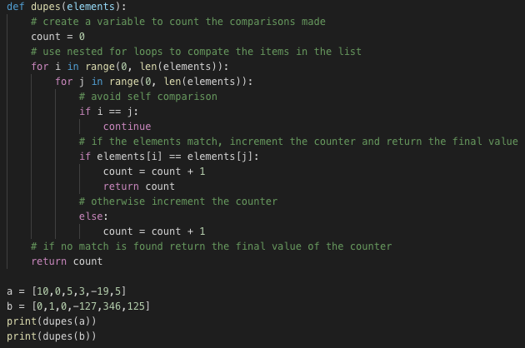
Output of the code is:

